**UCS 2611 Internet Programming Lab**

**Exercise 10. Three Tier Application with ReactJS, Node and MongoDB**

1. **Set up a MongoDB Database**
2. **Create a database called student**
3. 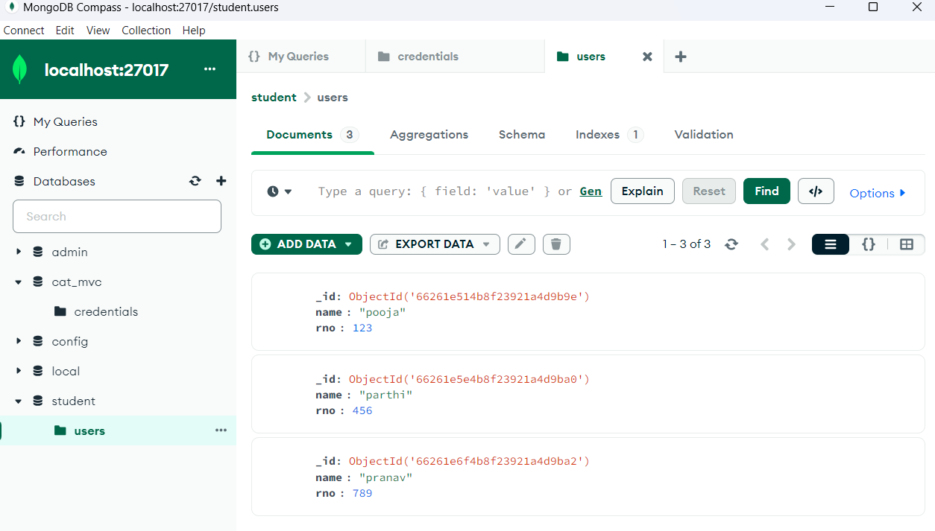**Create a collection called users**
4. **Create the following file structure**

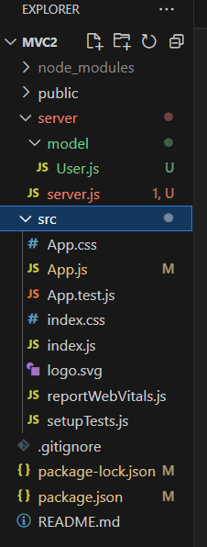

1. **Use the following code for each of the files**

**App.js: (client code)**

import {useEffect, useState} from 'react';

import axios from 'axios';

function App() {

  const [users, setUsers] = useState([]);

  console.log(users)

  useEffect(() => {

    axios.get('http://localhost:3001/getUsers')

      .then((users)=>{

        setUsers(users.data)

      }).catch(err=>{

        console.log(err)

      })

  },[]);

  return (

    <div>

      <h1>MVC architecture as client and server model</h1> {

      users.map(user=>{

        return <div>

              <h1>{user.name}</h1>

              <h1>{user.rno}</h1>

          </div>

      })

    } );

}

export default App;

**index.js:**

import React from 'react';

import ReactDOM from 'react-dom/client';

import './index.css';

import App from './App';

import reportWebVitals from './reportWebVitals';

const root = ReactDOM.createRoot(document.getElementById('root'));

root.render(

  <React.StrictMode>

    <App />

  </React.StrictMode>

);

**Server.js: (server code)**

const express = require("express");  //

const mongoose = require("mongoose");

const cors = require("cors");

const UserModel = require("./models/Users");

const app = express();

app.use(cors());

app.use(express.json());

mongoose.connect("mongodb://localhost:27017/student");

app.get("/getUsers", (req, res) => {

    UserModel.find({}).then(function(users){

        res.json(users);

    }).catch(function(err){

        res.json(err)

    })

});

app.listen(3001, () => {

    console.log("Server is running on port 3001");

})

**Users.js: (Model code)**

const mongoose=require('mongoose');

const userSchema=new mongoose.Schema({

    name:{

        type:String,

        required:true

    },

    rno:{

        type:Number,

        required:true

    }

})

const userModel=mongoose.model('users',userSchema);

module.exports=userModel;

1. **Install the required packages**
2. npm install express –save
3. npm install cors, axios, mongoose
4. **Start the server using the following command**

node server.js

1. **Open another terminal and start the React application (front-end)**

npm start

The output will be as follows:

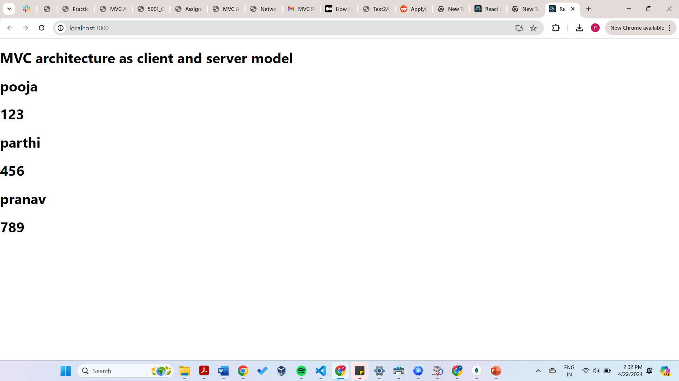

**Task:** Develop an application to validate the user credentials using login form.

**Best Practices to be followed:**

1. Design before coding

2. Incremental coding

3. Usage of proper naming convention

4. Usage of Comments to the code

5. Indentation of code